Interactive Art Generating Innovative Color Expression
Using Deep Learning Neural Networks

Yasuo Kuhara

Department of Interactive media, Faculty of Arts
Tokyo Polytechnic University
2-9-5 Honcho, Nakano, Tokyo, Japan
kuha@int.t-kougei.ac.jp

Abstract

This paper presents a progress report on our interactive art project using deep learning neural networks, which has been adopted as a private university research branding project on the research of color science and art. This project aims to produce interactive art with creative color expression by deep learning. Big data learning on media art enables AI artists or AI designers to generate novel expressions beyond the realms of human possibility.

Keywords-component; deep learning; neural networks; AI; interactive art; color; artist; media art;

I. Introduction

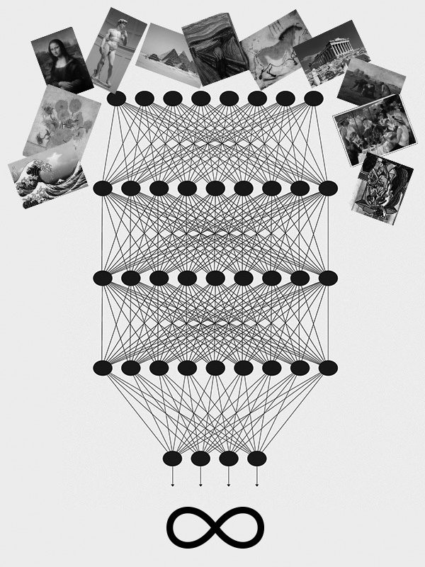
Artificial intelligence (AI) is applied to various fields. Deep learning has achieved remarkable results in image understanding, speech recognition and natural language processing. For example, in the board game Go, deep learning AI has won the professional human championship. Go requires intuitive ability rather than logical reasoning because it requires measurement of the difference between winning and losing from the two-dimensional position of black and white stones on the board. AI Go has been trained using an enormous amount of image data of past Go games using deep learning. In addition, it has played vast amounts of self-match simulations. As a result, it has obtained outstanding intuitive intelligence enabling it to beat known human standardized set sequences of gaming.
Another outstanding example is natural language processing, known as IBM Watson. It can learn a huge number of papers or documents and resolve professional problems, which previously was only possible by human experts such as lawyers, medical doctors, patent attorneys, etc. While humans require several years to acquire professional knowledge, AI can learn it in only a few hours.
Today, deep learning is applied to autonomous cars, drone home deliveries, customer-facing robots, etc. Furthermore, there are more interesting possibilities in the field of art, where intuitions and feelings are important. For example, applications that transform photographs to artist-styled paintings are very popular. Various tools and libraries for deep learning have been developed and made available on the Internet. However, we still need specialized knowledge about machine learning to use such services and they seem to be difficult for artists to use. Consequently, this study examines a methodology for applying deep learning to media arts and assisting in the production of creative work. By facilitating big data in media art and building art, deep learning has the potential to generate artwork beyond the realms of human intelligence, which would have a major impact on industry, culture, and society (see Fig. 1).

Fig. 1 Conceptual picture representing infinite possibilities of neural networks trained by huge data of artworks.
TABLE I
A brief history of machine learning featuring neural networks

Year | Event
1949 | Hebbian learning
1958 | Perceptron
 | 1st dark age ( impossibility of XOR )
1982 | Hopfield network
1985 | Boltzmann machine
1986 | Backpropagation
 | 2nd dark age ( limited computing ability )
2016 | Alpha Go

II. Overview of Neural Networks

There are various types of AI. This study focuses on artificial neural networks because of their heuristic learning capability (see Table I). They require no rule-based programming algorithm. Instead, they can learn behavior from training data.
In 1949, Hebb described Hebbian learning theory[1], which is a mathematical rule of synaptic plasticity in neurons of the brain during the learning process, where efficiency of synaptic connection arises from repeated and persistent stimulation of neurons. In 1957, Rosenblatt developed Perceptron[2], which is the first neural network with an optimizing algorithm to adjust the weight of synapse connections. In anticipation of its learning ability, various research programs were carried out. This was the first boom of neural networks. However, in 1969, Minsky showed that Perceptron is only capable of learning linearly separable patterns[3]. In other words, it is impossible to learn an XOR function. This discovery caused a significant decline in researcher interest. It took more than ten years for research on neural networks to be revitalized.
In 1986, Rumelhart developed the Backpropagation method, which induced the second boom of neural networks[4]. This method technically solved the limitation of Perceptron by using the gradient descent optimization algorithm by which errors are calculated at the output and distributed back through the network layers. Backpropagation is applied in various fields. For example, we developed neural networks for the prediction of enzyme function by feeding in the sequence of amino acids[5](see Fig. 2). Thus, neural networks seemed to have great potential ability. Nevertheless, at that time, computers did not have sufficient processing power to handle the work effectively required by large neural networks. Neural networks research slowed down until computers achieved far greater processing power. Therefore, they decreased in popularity during the 2000s.
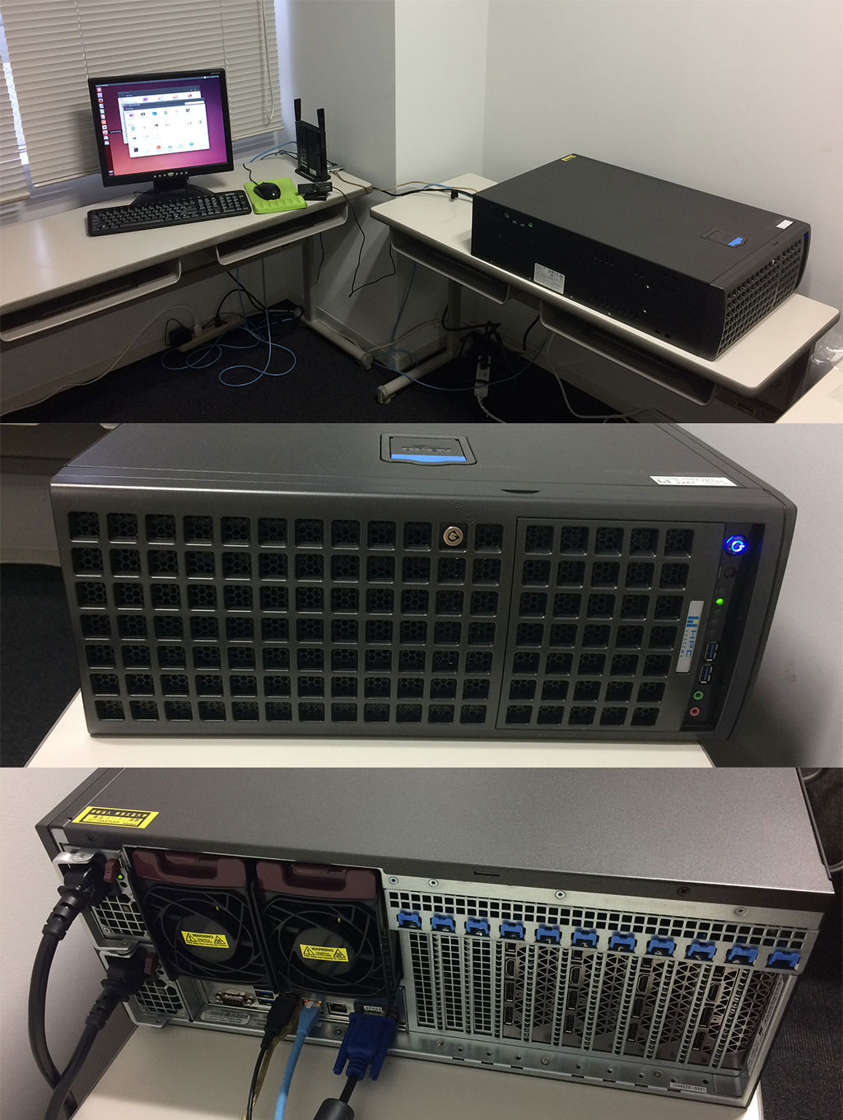

Fig. 3 GPGPU workstation HPC5000-XBWGPU4TS. Overview, front panel, and backside.
In the 2010s, powerful GPU-based computing systems and big data on the Internet enabled the seize of neural networks to be extended for extraordinary learning abilities, which is deep learning. This is the current boom of neural networks. In 2016, alpha GO beat a human champion and this surprising news reverberated around the world.
In summary, the basic theory of neural networks had already been established in the 1980s. However, we had to wait until the 2010s, when sufficient computational resources for their practical use were developed with the progress of information technology.

Fig. 2 Example of neural network. For prediction of enzyme function from amino acid sequence.
Amino Acid Sequence
Window Size
11 Residues
Input Layer
Hidden Layer
Output Layer
…
…
…
…

III. Building Environment

We can use personal computers to build deep learning systems to install a framework. For example, the Café of UC Berkley, Chainer of Preferred Networks and TensorFlow of Google are popular. However, it is not easy for normal users to install them, because they need various software or libraries such as C++, Python, Numpy, CUDA, etc. The most requested system is Ubuntu. Although Windows or MacOS are available, we have to use a command prompt like the UNIX system, which is familiar to engineers but unfamiliar to most users, especially artists. In addition, GPU is necessary for practical use to calculate learning, and software is required to control it. Actually, we cannot perform deep learning tasks without GPU. To run GPU, we need an extra power supply, because it consumes a lot of electricity running 24/7. The calculation time is several days, weeks, or sometimes months.
Second, a further solution is to use a highly specialized general-purpose computing on graphics processing units (GPGPU) workstation, which is a computer optimized for deep learning. However, this hardware is too expensive for personal use and requires a 24-hour, high-power electricity supply, which is costly. For this equipment, our project provided HPC5000 -XBWGPU4TS of HPC systems, which has a Xeon processor and GPU NVIDIA Tesla series, in a specialized computer room for deep learning using the facilities of our university (see Fig. 3). We can connect and use it through our university intranet.
To solve the difficult problem of providing an environment for deep learning, we can use the AI cloud service on the Internet. Many major IT companies provide a convenient learning cloud platform, for example, Amazon Machine Learning, Microsoft Azure Machine Learning, Google Cloud Platform, IBM Bluemix Watson API, Fujitsu AI Solution Zinrai platform service, etc.

IV. Deep Learning for Creative Art

In various fields, deep learning is applied and remarkable results have been reported. For example, many IT companies develop autonomous cars, drone delivery services, and voice assistant speakers. At an amusement park or theme park in the United States, the AI voice service is popular and many people utilize the voice service everywhere. Similarly, in the field of art, various trials are being conducted, for example, graphical painting, musical composition, story writing, etc.
Graphical painting is suitable for deep learning because neural networks can be trained using a large amount of imaging data. For example, “The Next Rembrandt” project of Microsoft can paint a picture just like Rembrandt by learning the picture data of Rembrandt as if the painter himself is painting it.
AI can compose music by learning musical data. For example, DeepBach can generate Bach hymn-like pieces by learning the styles of Bach's music, and Flow Machines can generate Beatles style music by learning all their pieces.
By using natural language processing, AI can write a short science fiction novel. In the Kimagure AI project, AI learned all the works of a specific writer and generated a new story, which was submitted to a contest and won a prize.
In the department of interactive media in our university, some students produced works of interactive art as their graduation thesis. For example, Solaris is a virtual planet on the screen and it learned the faces of the audience to display them orbiting the planet[6](see Fig. 4). As another example, MirrAI is an interactive installation with a half mirror, in which you can have a conversation with your virtual self in a mirror using a cloud AI service[7](see Fig. 5). However, these lack the capacity to use learning methods and are still being developed both technically and artistically. We need to establish a framework or guideline for producing artworks utilizing deep learning.
These cases of applying deep learning for art commonly use data of artworks for training neural networks in advance. Next, they generate similar artworks based on the trained neural networks. Some people do not regard this method as creation because AIs merely mimic past works by learning. This poses the question of what constitutes creativity. In my opinion, even human creators learn from past works in art history. They create something as consequence of the learned contents. In this context, AI does the same. We can therefore regard a work by deep learning as creation. In the near future, connecting AI technology and big data will generate unpredictable works far beyond the realms of human intelligence and emotion.

V. Conclusion

Due to a growing demand for AI, the shortage of AI-skilled engineers and artists is a serious problem. In 2020 when the Tokyo Olympics will be held, attractive color expression will be necessary. Interactive arts using deep learning are one of the solutions and embody the fusion of art and science. In this project of color science and art, we will promote the brand power of our university's culture.
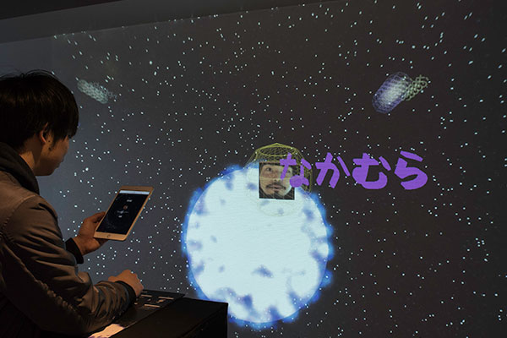
Fig. 4 Solaris. A student work using facial image learning.

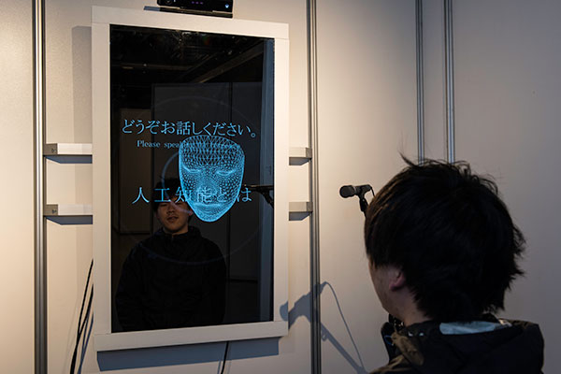
Fig. 5 MirrAI. A student work using speech recognition.

Acknowledgment

This research was supported by polytechnic color science and art creating tomorrow, studying the future, and connecting the world through color as a private university research branding project.

References

[1] D. Hebb, "The Organization of Behavior", New York: Wiley & Sons, 1949.
- F. Rosenblatt, "The Perceptron--a perceiving and recognizing automaton", Report 85-460-1, Cornell Aeronautical Laboratory 1957.
- M. Minsky, S. Papert, "Perceptrons: an introduction to computational geometry", MIT Press, 1969.
- D. E. Rumelhart, J. L. McClelland, "Parallel Distributed Processing: Explorations in the Microstructure of Cognition", Cambridge, MIT Press, 1986.
- Y. Kuhara, K. Shimizu, J. Doi, "Enzyme Function Prediction Using Neural Networks of Variable Topology", International Conference on Engineering Applications of Neural Networks, pp127-130, 1997
- Y. Tanaka, "Solaris", Graduation Exhibition, Tokyo Polytechnic University, 2017.
- Y. Chikada, "MirrAI", Graduation Exhibition, Tokyo Polytechnic University, 2017.

